S&M-CM/3G Data card/ 11-12/87 dt @ Chennai-6 the 03-01-12.

Sub : Introduction of unlimited 3G Data RCV in Prepaid services - reg
Ref : ECT Approval no.460 for CHTD Circle (incl TN Circle)

Approval of competent authority is hereby conveyed for the introduction of 3G Data RCV / FMC with different speed in Prepaid and Postpaid 3G mobile services in TN LSA (incl. CHTD) w.e.f. 04-01-2012

The tariff details are given below.

Monthly Charges | Prepaid
Amount (in Rupees per month) | Data Recharge Voucher (RCV) through CTOPUP only for Rs.992/- (Incl. of Tax)
Speed upto 5GB usage | Max. of 7.2mbps
Speed beyond 5GB | 100 kbps
Data and Validity | Unlimited Data  30 days from the date of use RCV

- Applicable to 3G special plan/3G Genl Customers and 3G data customers via FRC51 / Longer validity Data customers via FRCs 10740,10080,9450 in Prepaid customers
- This unlimited 3G Data RCV is in addition to the existing 12 Data RCVs in Prepaid services.
- This unlimited data RCV992 will add 5GB data usage to the existing data, if any, during the day/any time usage. The customer can browse with full speed of 7.2mbps max. Once the available day/any time data becomes zero, the customer can enjoy the unlimited data with100kbps only including the Night usage, if any.

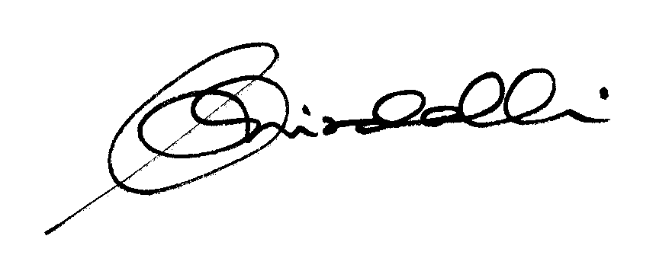

(K.R. Aravindavalli)

AGM(Marketing-CM)

TN Circle, Chennai-6

To
GM (NW-O CM), Trichy -1/ Coimbatore – For information & necessary action please.
GM(S&M-CM), Chennai Telephones, Chennai – for information please.
GM (F) / Sr. GM (TR) TN Circle, Chennai for information please.
DGM In charge IN – Trichy/Bangalore - for necessary action please.
DGM/DE Billing & IT – Trichy for information & necessary action please.
DGM (N/W-O-CM)/DE Commercial Coimbatore - For information & necessary action please.
Heads of SSAs, -- for kind information and necessary action please.
DGM (Sales), AGM (Sales) & AGM (MKTG II)- Chennai-6 –For information and informing Sales Heads , franchisee managers and retail managers and other Channel partners along with commission structure as applicable.
DGM (CS), Chennai-6 - For information and informing Call Centre/Customer Service Centre Officials and ensure uploading the information on the website “tamilnadu.bsnl.co.in” .
DGM (S&M-CM)/AGM (MKTG-CM), Chennai Telephones, Chennai – for information & necessary action please.

